Comrie's Use Only

Family Code ________________________

Qualification Expiry Date ______________
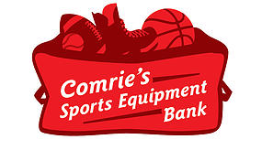

Comrie's Sports Equipment Bank
Parent/Guardian Application for Equipment

Parent/Guardian (One CURRENT qualification document is required at the time of application)
Name
Street Address
City |  | Postal Code
Phone | Email Address

Children in Your Family
(Children must be present at the time of pick up to get fitted properly. Call for appointment.)
Name | Age | Sport(s)

Qualifying Documentation
(At least one current document is required)

KidSport Approval Letter and/or Email | Jumpstart Approval Letter
Alberta Child Health Benefit Letter and Card | A.I.S.H Approval Letter and Monthly Slip
Alberta Child Care Subsidy Approval Letter | Flames EvenStrength Program
Alberta Income Assistance Monthly Slip | Airdrie Participant Support Program Card
Calgary Fee Assistance (Fair Entry Program) Card

Qualifying Document Information
(Complete the following AND attach a copy so we can verify your family household income for approval.)
Documentation Type _______________________________________________________________
Qualification Expiry Date ___________________________________________________________
Document Verification
Card Number (if applicable)__________________________
Letter Date (if applicable)____________________________
Submit Application to:

Adriel Allen by email at adriel@comriessports.org, by fax at 403-569-1147, or by mail at 3557 52nd Street SE Calgary, AB T2B 3R3.

